Homework write up:  
I started this program the same as the last one except that I said if(args.length != 1) because we are only passing one argument this time. I also initialize the startTime of the program at the top. If args.length != 1 then the program will stop and display the correct usage.

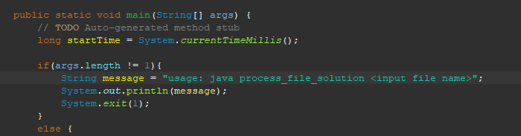

The else statement starts off my taking the first argument inside of args, then it uses that file name it makes a file object which is then thrown into the scanner object so that we can use the scanner to start reading the file. After that I initialize the variables of what we need. Sum, max, min, and lines processed.

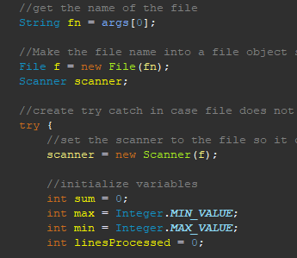

After that I use the scanners built in function of hasNextInt() this function will read the given file only while there is a next integer to read. Inside the while loop, I calculate the sum, max, min, and add all the lines it is processing. After that I used the same logic as I did in the generate program to get the total time the program took to run in seconds. Then I calculate the average of the ints inside of the file as well as calculate the lines per second by dividing the total lines processed by how many seconds the program took to run. After that I print the results.

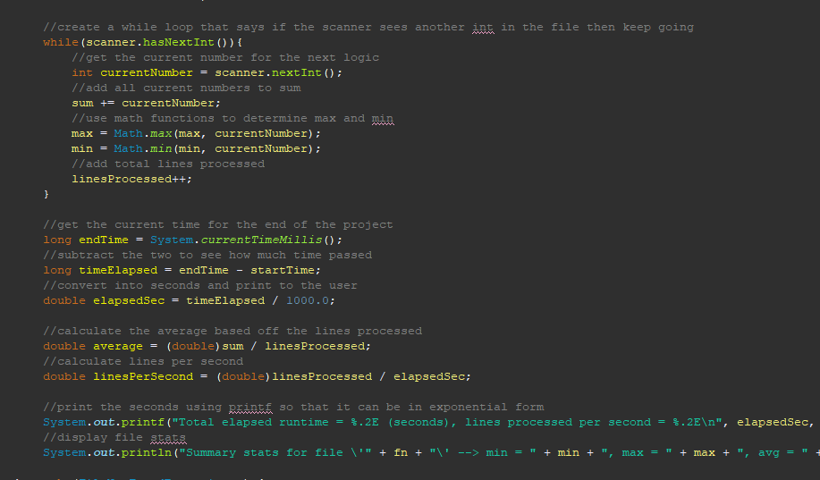

All of this code is placed inside of a Try Catch so that just incase the file is not found. The program will not be blown up.

Homework screen shots:

